Instructions for Moodle

1. You will need to log in. On the far right of the screen you will see the Login boxes.
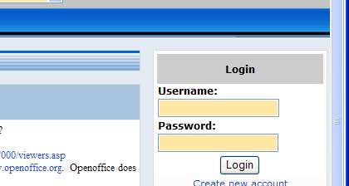
a. Click in the Username: box and key your givenname.familyname
b. Click in the Password box and key: Temporary1 (be certain to capitalize the first letter and there is no space between the word Temporary and the number 1.
c. Click the Login box. This will take you to a screen to change your password to one that you want.
1) Key the old password, Temporary1, again
2) Key a new password that is unique to you that other will people will not know (but that you can remember!)
3) Retype the new password again
4_ Click OK.

This should bring you to a screen where it says “You are logged in as your name (Logout)
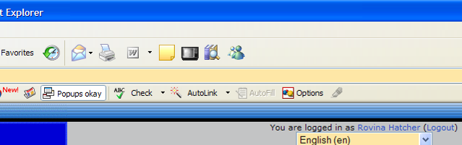

Note: We have a few times when this did not work. Change the password again and it should work.

A screen will display telling you that the Password change was successful. Click Continue.

2. On the far left of the screen, click on the appropriate semester and year below Course categories. (If the professor has already enrolled you in the class, the course will be listed. You can skip to Step 3)
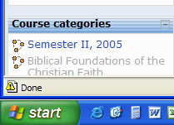

You will need to find your course. There are two pages to show all the courses. Courses are listed alphabetically by course number.

a. Click on your course name to open the coursesite

b. Enroll in the course by using the course key given to you by your instructor. You should be able to see the course home page that will display the weeks or the information placed their by your professor
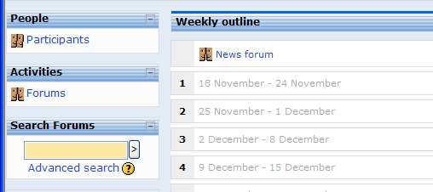

3. Edit your profile
a. Click on Participants on the left side under People.
b. Click on your name in the list. This will take you to a page that lists your Profile.
c. Click the Edit profile tab at the top.
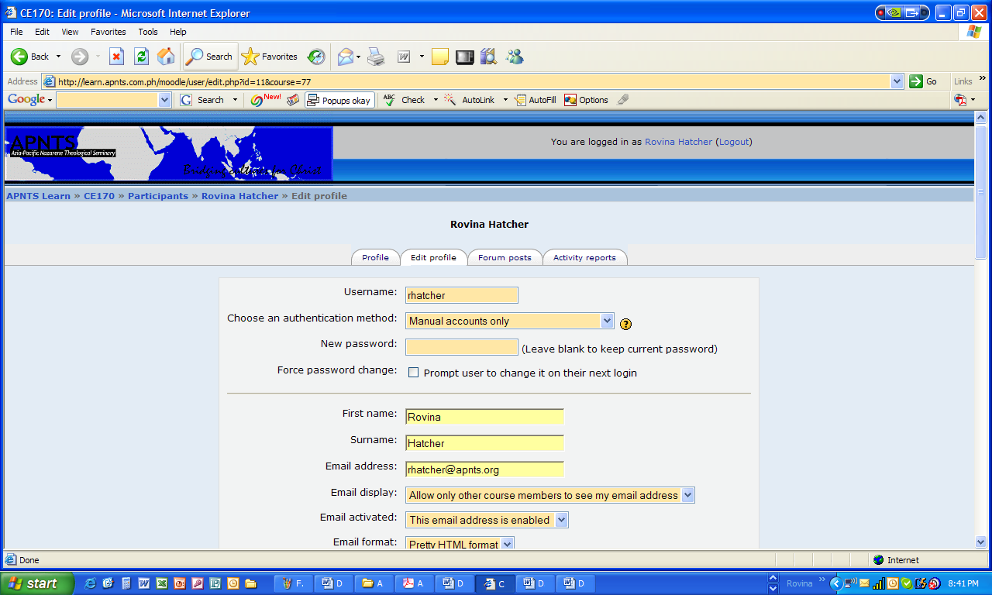
1) Do not change anything above the divide line (unless you want to change your password again)
2) Add information to the items below the divide line. You can add a description of yourself, a picture, etc.
Note: To add a picture, you must first have a picture saved on the computer or on a disk/flash drive, etc.
a) Click the Browse button on the right side of the “New Picture” text box to open the Choose File dialog box.
b) Locate your picture on your computer.
c) Select the picture file
d) Click the Open button
3) When finished, scroll down and click the Update Profile button at the bottom of the page.
4) A page should display saying Changes Saved. Click the Continue button to go back to your Profile and see the additions and changes you made.
d. If you are satisfied with your profile, click the Course ID at the top of the page to return to the course home page.

Congratulations! You have logged in to Moodle, changed your password, enrolled in a class, and updated your profile!

Explore some more. Click on the links to see what else is here. When you are finished, click on Logout at the top right. Happy Moodle-ing!

